**MODULE 5**

1. **What do you understand By Database**

**Ans:-** A database is an organized collection of data that is stored and managed so that it can be easily accessed, updated, and analyzed. Databases are used to store information in a structured way, typically using tables, and they allow users to perform various operations such as retrieving data, inserting new records, updating existing data, and deleting unwanted information.

1. **What is Normalization?**

**Ans:-** Normalization in a Database Management System (DBMS) is the process of organizing data within a database to minimize redundancy and improve data integrity. It involves dividing large, complex tables into smaller, simpler tables and establishing relationships between them using keys (primary and foreign). The main goal is to reduce data duplication and ensure that data dependencies make sense, leading to a more efficient and scalable database structure.

1. **What is Difference between DBMS and RDBMS?**

**Ans:-**

**1 Data structure:**

* **DBMS (Database Management System):-** Stores data as files. Data is generally organized in a hierarchical or navigational format, but not in a structured table form.

• Example: XML databases, file systems.

* **RDBMS**(**Relational Database Management System**):

Stores data in the form of tables (rows and columns) that are related to one another via keys (primary keys, foreign keys). This follows a relational model.

Example: MySQL, PostgreSQL, Oracle, Microsoft SQL Server.

**2. Relationships:**

* **DBMS**:does not support the concept of relationships between data. Data is managed without any explicit link between datasets.
* **RDBMS**:Supports relationships between tables through foreign keys, allowing complex queries to retrieve related data.
* **Summary of Differences:**

| **Feature** | **DBMS** | **RDBMS** |
| --- | --- | --- |
| **Data Storage** | Files, navigational/hierarchical | Tables (relational model) |
| **Relationships** | No relationships between data | Supports relationships using keys |
| **Normalization** | Not enforced | Fully supports normalization |
| **Data Integrity** | Manual enforcement | Automatic enforcement via constraints |
| **ACID Properties** | Not followed strictly | Strictly follows ACID properties |
| **Redundancy** | High | Low due to normalization |
| **Scale** | Small-scale, single-user | Large-scale, multi-user |

1. **What is MF Cod Rule of RDBMS Systems?**

**Ans:-**

**1.Guaranteed Access Rule:** Every data item should be accessible via a combination of a table name, primary key, and column name.

**2.Systematic Treatment of Null Values:** The system must support null values to represent missing or inapplicable information.

**3.Dynamic Online Catalog Based on the Relational Model:** Metadata should be stored in the same way as regular data, allowing users to query it using SQL.

**4.Comprehensive Data Sublanguage Rule:** The database must support a comprehensive language that handles data definition, manipulation, and transactions.

**5. View Updating Rule:** Views must be updatable if theoretically possible.

**6. High-Level Insert, Update, and Delete:** The system should support set-based operations for insert, update, and delete.

**7. Physical Data Independence:** Changes to the physical storage of data should not require changes to the application.

**8. Logical Data Independence:** Changes to the logical schema (e.g., tables, columns) should not affect applications.

**9. Integrity Independence:** Integrity constraints must be stored in the catalog and not in the application programs.

**10. Distribution Independence:** The end-user should not be aware of whether the data is distributed across multiple locations.

**11. Non-Subversion Rule**: If there is a way to access the data without using the RDBMS's query language, it should not be able to bypass the integrity rules.

1. **What do you understand By Data Redundancy?**

**Ans:-**

**Increased Storage Costs:** Storing the same data multiple times can lead to wasted storage space, which can be costly, especially with large datasets.

**Data Inconsistency:** When data is redundant, there is a risk of inconsistencies arising if one copy of the data is updated while another is not. This can lead to incorrect or outdated information being presented to users.

**Maintenance Challenges:** Redundant data requires additional effort to maintain, as updates need to be propagated to all copies of the data. This can make database management more complex and error-prone.

**Potential for Anomalies:** Data redundancy can lead to anomalies, such as update anomalies (where changes in data require updates in multiple places), insert anomalies (difficulty in adding new data due to missing information), and delete anomalies (removal of data that might accidentally result in losing other important information).

**6. What is DDL Interpreter?**

**Ans. Parsing and Validation:** The DDL Interpreter first parses the DDL commands to ensure they are syntactically correct. It also validates the commands against the database schema and other constraints to ensure they are semantically correct.

**Execution:** Once the DDL commands are parsed and validated, the DDL Interpreter executes them by modifying the database's metadata. This involves creating, altering, or deleting tables, columns, indexes, and other database objects as specified**.**

**Metadata Management:** The DDL Interpreter updates the system catalog or data dictionary, which is a special set of tables that store metadata about the database objects. This includes information about the structure and constraints of the database.

**Transaction Management:** Some database systems support transactional DDL, where changes made by DDL commands can be committed or rolled back. The DDL Interpreter handles these transactions to ensure atomicity and consistency.

**7. What is DML Compiler in SQL?**

**Ans. Parsing:** The DML Compiler first parses the DML statement, breaking it down into its constituent parts such as keywords, table names, column names, and values. This step involves checking the syntax of the SQL statement to ensure it conforms to the language's grammar rules.

1. **Semantic Analysis:** After parsing, the DML Compiler performs semantic analysis to verify that the SQL statement is meaningful in the context of the database schema. This includes:
   * Checking that the specified tables and columns exist.
   * Ensuring data types are compatible.
   * Verifying that the statement respects integrity constraints (e.g., foreign key constraints).
   * Ensuring that the user has the necessary permissions to execute the command.
2. **Query Optimization:** One of the key functions of the DML Compiler is to optimize the query for efficient execution. This involves:
   * Analyzing different ways to execute the query.
   * Selecting the most efficient execution plan, which may involve choosing the best indexes, join strategies, and access paths.
   * Reordering operations to minimize the computational cost, such as reducing the number of I/O operations.
3. **Code Generation:** The DML Compiler translates the optimized query plan into a set of low-level instructions that the database engine can execute. This executable code is tailored to the database's internal architecture and is designed to perform the data manipulation operations as efficiently as possible.
4. **Execution:** While the DML Compiler itself does not execute the code, it prepares the execution plan. The compiled code is then handed over to the database engine's execution component, which carries out the operations on the database.

**8. What is SQL Key Constraints writing an Example of SQL Key Constraints**

**Ans.** **Primary Key Constraint:** Ensures that each row in a table is uniquely identifiable. A primary key cannot contain NULL values and must contain unique values.

**Foreign Key Constraint:** Ensures that the value in a column or a group of columns matches values in a column of another table, enforcing referential integrity between tables.

**Unique Constraint:** Ensures that all values in a column or a group of columns are unique across all rows in the table.

**Check Constraint:** Ensures that all values in a column satisfy a specific condition.

**Not Null Constraint:** Ensures that a column cannot have NULL values.

**9. What is save Point? How to create a save Point write a Query ?**

**Ans. Transaction Management:** Savepoints are used within transactions, which are sequences of SQL statements that are executed as a single unit of work. Transactions ensure that operations are atomic, consistent, isolated, and durable (ACID properties).

**Partial Rollback:** By creating savepoints, you can roll back to a specific point within a transaction, undoing only certain parts of the transaction instead of rolling back the entire transaction.

**Nested Transactions:** Savepoints can be considered a form of nested transactions, where you can revert to an earlier state within the main transaction.

**10.What is trigger and how to create a Trigger in SQL?**

**Ans. Automatic Execution:** Triggers are executed automatically when a specified event occurs on the associated table or view.

**Event-Driven:** They respond to events such as data modifications (INSERT, UPDATE, DELETE).

**Timing:** Triggers can be set to execute **BEFORE or AFTER** the event.

* **BEFORE Trigger:** Executes before the event occurs, allowing modifications or validations before the actual data change.

**AFTER Trigger:** Executes after the event occurs, allowing actions to be taken once the data has been changed. **Row-Level vs. Statement-Level:**

* **Row-Level Trigger:** Executes once for each row affected by the event.
* **Statement-Level Trigger:** Executes once per SQL statement, regardless of the number of rows affected.

1) create database st77;

CREATE TABLE H45(Rollno int PRIMARY key AUTO_INCREMENT not null

name varchar(20),branch varchar(20) );

insert into H45(name , branch) values

(“jay”, computer sci )

(“suhani”, Elctronic and com)

(“kirit”, Elctronic and com)

* CREATE TABLE E21(ERollno int, S_code varchar(20), Marks int, P_code varchar(20),
* FOREIGN KEY (ERollno) REFERENCES h45(Rollno) );
* INSERT INTO E21(Erollno, S_code ,Marks, P_code)VALUES
* (1,"CS11",50,"CS"),
* (1,"CS12",60,"CS"),
* (2,"EC101",66,"EC"),
* (2,"EC102",70,"EC"),
* (3,"EC101",45,"EC"),
* (3,"EC102",50,"EC");

2) create database employee;

Create table emp(Employee id int primary key auto increment not null,

First_name varchar(20),

last_name varchar(20),

salary bigint , joining_date varchar ,department varchar(20) );

insert into emp(First_name, last_name , salary,joining_date, department)VALUES

("johan", "Abrahan" , 10000000 ,"01-JAN-13 12.00.00 AM","banking" ),

("Mitchal", "clarke", 8000000 ,"01-JAN-13 12.00.00 AM","insurance" ),

("Roy", "Thomes", 7000000 ,"01-FEB-13 12.00.00 AM","banking" ),

("Tom" , "jose" ,6000000,"01-FEB-13 12.00.00 AM","insurance"),

("jerry" , "pinto" , 650000 ,"01-FEB-13 12.00.00 AM", "insurance"),

("Philip" , "Mathew" , 750000 ,"01-JAN-13 12.00.00 AM", "service"),

("test name 1" ," 123" , 650000 ,"01-JAN-13 12.00.00 AM", "service"),

("teat name 2", "lname % ", 600000 ,"01-FEB-13 12.00.00 AM", "insurance");

CREATE TABLE Incentive(Employee_refer_id int, Incentive_date int ,Incentive_amount bigint);

Insert into Incentive(Employee_refer_id , Incentive_date ,Incentive_amount );

(1,01-feb-13,5000),

(2,01-feb-13,3000),

(3,01-feb-13,4000),

(1,01-feb-13,4500),

(2,01-feb-13,3500);

4) SELECT FIRST_NAME, Joining_Date, Salary FROM employee;

5) SELECT * FROM emp ORDER BY First_Name ASC, Salary DESC;

6) Select*From emp Where First_name like 'j%';

7) SELECT emp MAX(salary) AS max_salary FROM employee;

8) SELECT*From emp order by Asc;

9) SELECT e.first_name, i.incentive_amount FROM emp JOIN incentives ON e.employee_id = i.employee_id WHERE i.incentive_amount > 3000;

10)

DELIMETER$$

BEGIN

CREATE TABLE emp_trigger (tid int PRIMARY KEY AUTO_INCRIMENT,

TFirst_name varchar(20), Tlast_name varchar(20), Tsalary varchar(50), Tjoinigdate varchar(20),

Tdeparment varchar(20), Action_perform varchar(60) )

End;

CREATE TRIGGER trigger01 BEFORE DELETE ON emp for EACH ROW

INSERT INTO emp_trigger(tid, tFirst_name, t_lastname, tsalry , tprice, t_department ,Action_perform) VALUES

(old.id ,old.firstname, old.lastname , old.salary ,old.price ,old.price , old department)

3) CREATE DATABASE h777;

CREATE TABLE Salesperson(pk_snno int, Sname varchar(20), city varchar(20),

Comm int);

Insert Into Salesperson(pk_sunno,sname,city,Comm) VALUES

(1001,"Peel","London",.12),

(1002,"Serrees","San jose",.13),

(1004,"Motika","london",.11),

(1007,"Rafkin","barcelona",.15),

(1003,"Axelrod","new york",.1);

CREATE TABLE Customer(pk_Cnm int,cname varchar(20),city varchar(20),Rating bigint,Fk_snno int);

INSERT INTO customer(pk_Cnm,cname,city,Rating,Fk_snno) VALUES

(201,"Hoffman","London",100,1001),

(202,"Giovanne","Roe",200,1003),

(203,"Liu","San jose",300,1002),

(204,"Grass","Barcelona",100,1002),

(206,"Clemens","London",300,1003),

(207,"Pereira","Roe",100,1004);

13) [SELECT](http://localhost/phpmyadmin/url.php?url=https://dev.mysql.com/doc/refman/8.0/en/select.html) cname FROM customer WHERE rating > 100;

14) SELECT name, city FROM salesperson WHERE city = 'London' AND commission > 0.12;

15) SELECT name, city FROM salesperson WHERE city = 'Barcelona' OR city = 'London';

16) SELECT name, city, commission FROM salespeople WHERE commission > 0.10 AND

commission < 0.12;

17) SELECT customer_name, city, rating FROM customers WHERE rating > 100 OR (city = 'Rome' AND rating <= 100);

2) CREATE TABLE employee(employee_id int PRIMARY KEY AUTO_INCREMENT ,

First_name varchar(40),

Last_name varchar(40),

salary int,

joining_date varchar(40),

Department varchar(40)

);

INSERT INTO employee(employee_id,First_name,Last_name,salary,joining_date,Department)

VALUES(1,"john","Abraham",1000000,"01-jan-13 12.00.00 AM","Banking"),

(2,"michale","clarke",800000,"01-jan-13 12.00.00 AM","Insurance"),

(3,"Roy","Thomas",700000,"01-feb-13 12.00.00 AM","Banking"),

(4,"Tom","Jose",600000,"01-feb-13 12.00.00 AM","Insurance"),

(5,"Jerry","Pint0",650000,"01-feb-13 12.00.00 AM","Insurance"),

(6,"Phillip","Mathew",750000,"01-jan-13 12.00.00 AM","Services"),

(7,"TestName1","123",650000,"01-jan-13 12.00.00 AM","Services"),

(8,"TestName2","LName%",600000,"01-feb-13 12.00.00 AM","Insurance");

CREATE TABLE Incentive(Employee_ref_id int,

Incentive_date varchar(40),

Incentive_amount int

);

INSERT INTO incentive(Employee_ref_id,Incentive_date,Incentive_amount)

VALUES(1,"01-FEB-13",5000),

(2,"01-FEB-13",4000),

(3,"01-FEB-13",3000),

(1,"01-JAN-13",4500),

(2,"01-JAN-13",3500);

3) SELECT First_name

FROM employee

WHERE First_name = 'tom';

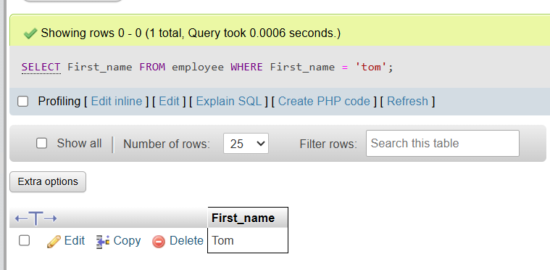

4) SELECT First_name AS First_name,

joining_date AS Joining_Date,

salary AS salary

FROM employee;

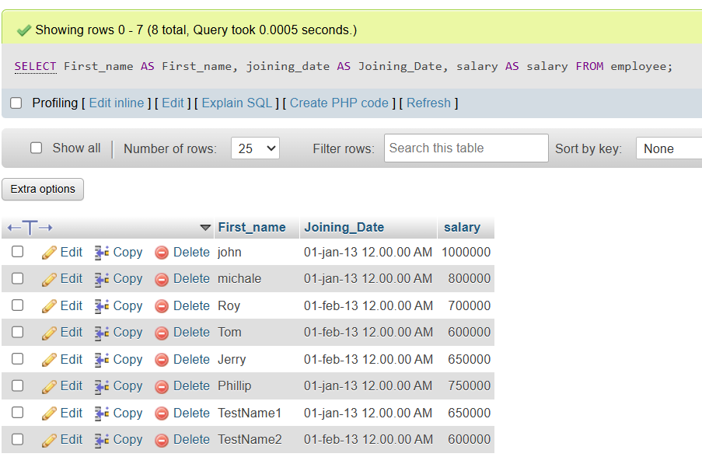

5) SELECT *

FROM employee

ORDER BY First_name ASC,salary DESC;

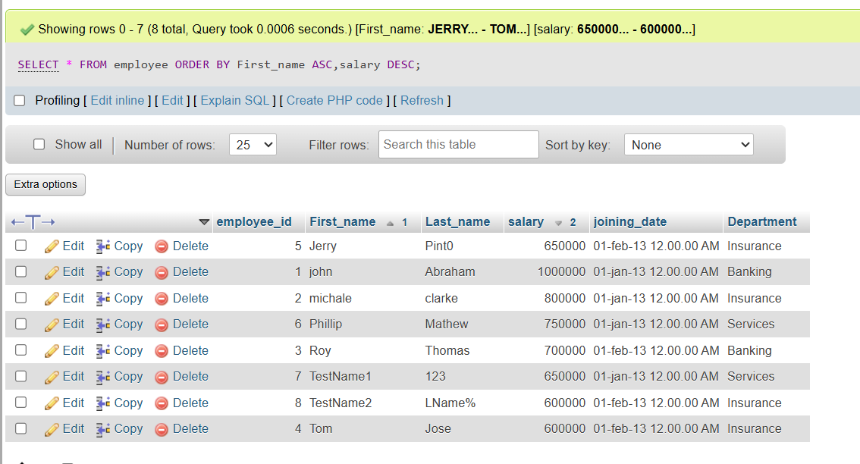

6) SELECT *

FROM employee

WHERE First_name LIKE '%J%' ;

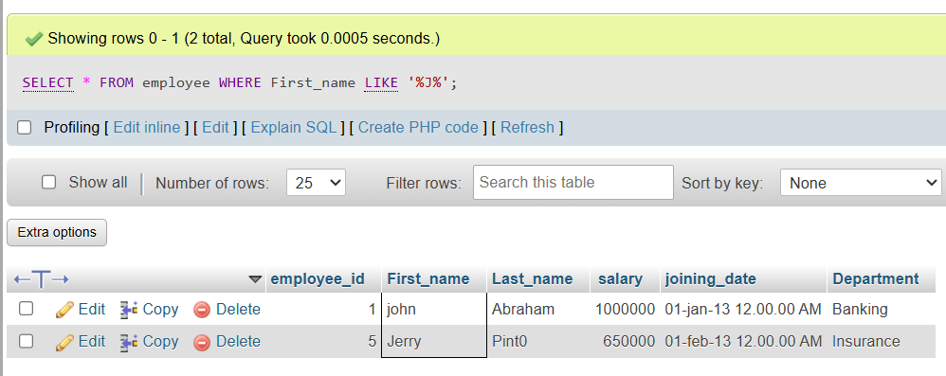

7,8) SELECT Department,MAX(salary) AS max_salary

FROM employee

GROUP BY Department

ORDER BY max_salary ASC;

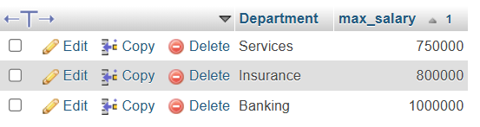

9) SELECT e.First_name AS First_name,i.incentive_amount

FROM employee e

JOIN incentive i ON e.employee_id = i.Employee_ref_id

WHERE i.Incentive_amount > 3000;

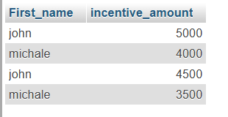

10 ) CREATE TABLE viewtable(

employee_id int ,

First_name varchar(40),

Last_name varchar(40),

salary int,

joining_date varchar(40),

department varchar(40)

);

DELIMITER //

CREATE TRIGGER AFTER_employee_insertes

AFTER INSERT ON employee

FOR EACH ROW

BEGIN

INSERT INTO viewtable (employee_id,First_name,Last_name,salary,joining_date,department)

VALUES(NEW.employee_id,NEW.First_name,NEW.Last_name,NEW.salary,NEW.joining_date,NEW.department);

END;

//

DELIMITER ;

INSERT INTO employee (First_name,Last_name,salary,joining_date,department)

VALUES("John","Doe",60000,"15-JAN-2024","Engineering");

11) CREATE TABLE SALSEPERSON(SNO int PRIMARY KEY,

SNAME varchar(40),

CITY varchar(40),

COMN Decimal(4,2));

INSERT INTO salesperson(SNO,SNAME,CITY,COMN)

VALUES(1001,"Peel","London",.12),

(1002,"Serres","San Jose",.13),

(1003,"Motika","London",.11),

(1007,"Rafkin","Barcelona",.15),

(1003,"Axelrod","New York",.1);

11) CREATE TABLE Customer(CNO int PRIMARY KEY,

CNAME varchar(40),

CITY varchar(40),

RATING int,

SNO int

);

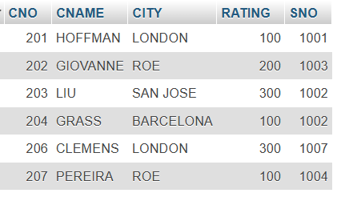

13) SELECT CNAME

FROM customer

WHERE RATING > 100;

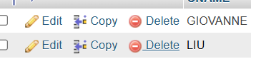

14) SELECT SNAME, CITY

FROM salseperson

WHERE CITY = "LONDON" AND COMN > 0.12;

15) SELECT SNAME,CITY

FROM salseperson

WHERE CITY = "BARCELONA" OR CITY = "LONDON" ;

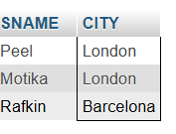

16 ) SELECT SNAME, CITY ,COMN

FROM salseperson

WHERE COMN > 0.10 AND COMN < 0.12;

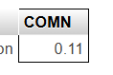

17) SELECT CNAME,CITY,RATING

FROM customer

WHERE RATING > 100 OR CITY = "ROME";

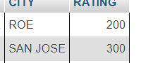

18) SELECT *

FROM salseperson;

19) CREATE TABLE SALESMEN (SALESMEN_ID int,

NAME varchar (40),

CITY varchar(40),

COMMISSION DECIMAL (4,2)

);

INSERT INTO salesmen (SALESMEN_ID,NAME,CITY,COMMISSION)

VALUES(5001,"JAMES HOOG","NEW YORK",0.15),

(5002,"NAIL KNITE","PARIS",0.13),

(5005,"PIT ALEX","LONDON",0.11),

(5006,"MC LYON","PARIS",0.14),

(5007,"PAUL ADAM","ROME",0.13),

(5003,"LAUSON","SAN JOSE ",0.12);

CREATE TABLE ORDERS(ORD_NO INT PRIMARY KEY,

PURCH_AMT DECIMAL(10,2),

ORD_DATE VARCHAR(40),

CUSTOMER_ID INT,

SALESMAN_ID INT

);

INSERT INTO orders(ORD_NO,PURCH_AMT,ORD_DATE,CUSTOMER_ID,SALESMAN_ID)

VALUES(70001,150.50,'2012-10-05',3005,5002),

(70009,270.65,'2012-09-10',3001,5005),

(70002,65.26,'2012-10-05',3002,5001),

(70004,110.5,'2012-08-17',3009,5003),

(70007,948.5,'2012-09-10',3005,5002),

(70005,2400.6,'2012-07-27',3007,5001),

(70008,5760,'2012-09-10',3002,5001),

(70010,1983.43,'2012-10-10',3004,5006),

(70003,2480.4,'2012-10-10',3009,5003),

(70012,250.45,'2012-06-27',3008,5002),

(70011,75.29,'2012-08-17',3003,5007),

(70013,3045.6,'2012-04-25',3002,5001);

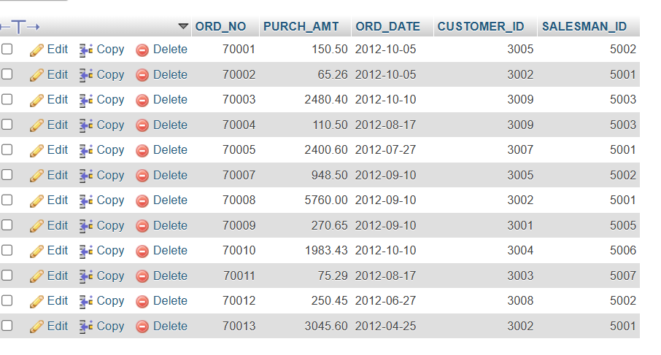

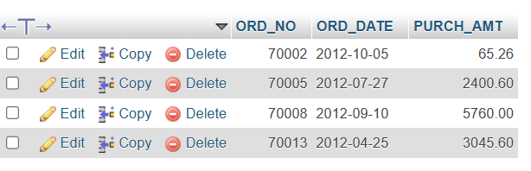

20) CREATE TABLE item_mast(PRO_ID int PRIMARY KEY,

PRO_NAME varchar(40),

PRO_PRICE decimal(10,2),

PRO_COM INT

);

INSERT INTO item_mast(PRO_ID,PRO_NAME,PRO_PRICE,PRO_COM)

VALUES(101,"MOTHER BOARD",3200.00,15),

(102,"KEY BOARD",450.00,16),

(103,"ZIP DRIVE",250.00,14),

(104,"SPEAKER",550.00,16),

(105,"MONITOR",5000.00,11),

(106,"DVD DRIVE",900.00,12),

(107,"CD DRIVE",800.00,12),

(108,"PRINTER",2600.00,13),

(109,"REFILL CARTRIDGE",350.00,13),

(110,"MOUSE",250.00,12);

SELECT PRO_ID,PRO_NAME,PRO_PRICE,PRO_COM

FROM item_mast

WHERE PRO_PRICE BETWEEN 200 AND 600;

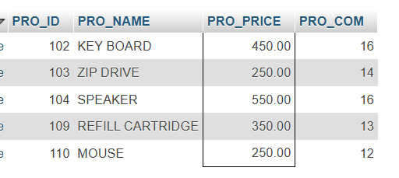

21) SELECT AVG (PRO_PRICE) AS avg_price

FROM item_mast

WHERE PRO_COM = 16;

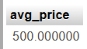

22) SELECT PRO_NAME AS 'Item_Name',PRO_PRICE AS 'Price in Rs.'

FROM item_mast;

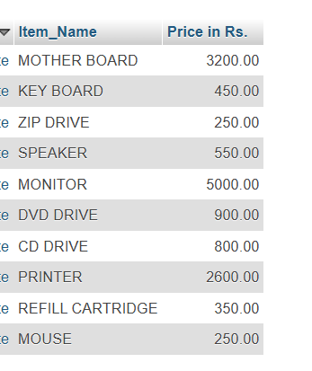

23) SELECT PRO_NAME,PRO_PRICE

FROM item_mast

WHERE PRO_PRICE>=250

ORDER BY PRO_PRICE DESC , PRO_NAME ASC ;

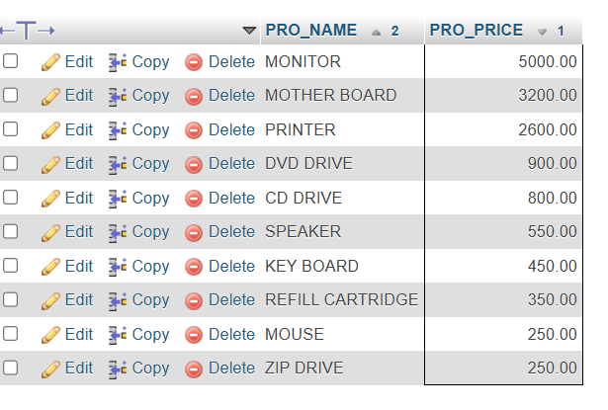

24) SELECT PRO_COM AS company_code,AVG (PRO_PRICE) AS average_price

FROM item_mast

GROUP BY PRO_COM;

